Synopsis

Project Title

Problem Id:

Student Name
University Roll number
Section

- Problem Description:
Explain the problem statement and its role in real life (max 200 words).

- Steps of Implementation:
This section should explain the each phase of ML pipeline used.
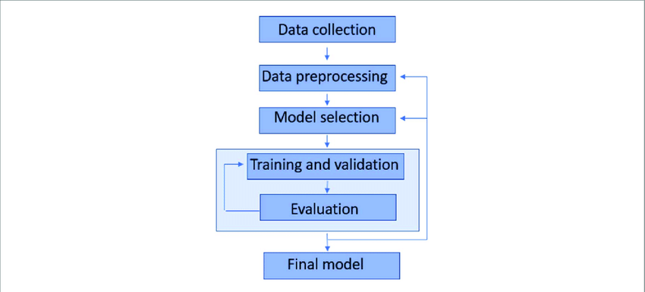
Fig. 1 Sample architecture
- Expected Modules/ Libraries to be used :
List all the inbuilt and custom modules used with 1-2 line description of each.

- Expected Evaluation metrics and Plots to be used:
In this section explain which evaluation metrics and visualization plots you are planning to use and why.

- Required topics from the subject:
Ex strings, pointers, files etc.
(write 2 to 3 lines in each topic)
- Platform Required:
Visual studio/ jupyter notebook/ python idle.
- Books and Link Sources:
At least 4

